PROJECT REPORT

1. INTRODUCTION
   1. Overview :

Creating a strong brand identity is essential for any business. In this topic, we will explore the process of crafting a brand name, designing a brand logo, and establishing a brand email ID. These elements are crucial for conveying your business's identity, building recognition, and fostering trust among your target audience. A well-thought-out brand identity can set you apart in a crowded marketplace, leaving a lasting impression and facilitating effective communication with customers and partners. Let's delve into the steps and considerations involved in each of these aspects to help you establish a compelling brand identity for your business

1.2 Purpose :

The purpose of this topic is to provide comprehensive guidance on the fundamental components of brand identity creation: choosing an impactful brand name, designing a memorable brand logo, and setting up a brand-specific email ID. By understanding the principles and strategies behind each of these elements, individuals and businesses can effectively shape their brand's image, communicate their values, and establish a cohesive and recognizable identity. Whether you're a startup or an established company looking to refresh your brand, this information will empower you to make informed decisions that resonate with your target audience and contribute to your long-term success in the marketplace

1. PROBLEM DEFINITION AND DESIGN THINKING

2.1 Empathy map:

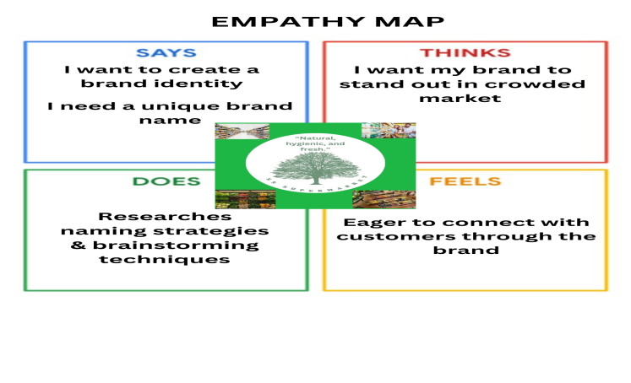

2.2 IDEATION AND BRAINSTORMING

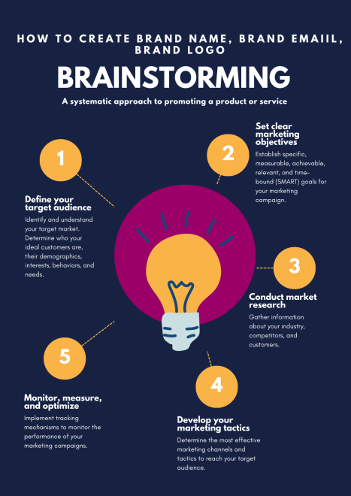

1. RESULT :



We have done market research on our brand logo , And the output of the logo was unexpectedly good.

ADVANTAGES:

1. Recognition and Trust: A well-crafted brand identity fosters recognition and trust among customers, making it more likely for them to engage with your business.

2.Competitive Edge: A unique brand name, compelling logo, and professional email ID can help you stand out in a crowded marketplace.

3. Effective Communication: A branded email ID enhances the professionalism of your communication, helping you connect with customers and partners more effectively.

4. Reflects Values: Your brand identity can convey your brand's values and mission, enabling customers to align with your business on a deeper level.

5. Cohesion: A consistent brand identity across various platforms and materials creates a cohesive and unified image for your business.

DISADVANTAGES:

1. Cost: Developing a professional brand identity, including logo design, may require a financial investment that some small businesses or individuals may find challenging.

2. Time-Consuming: The process of brainstorming, designing, and refining a brand identity can be time-consuming, potentially delaying the launch of your business or project.

3. Choosing the Wrong Elements: If not done carefully, choosing the wrong brand name, logo, or email ID can have a detrimental effect on your business's image and success.

APPLICATION:

1. Business Startups: Entrepreneurs launching new businesses can use this process to establish a strong brand presence from the outset. It helps them stand out in their industry and build trust with potential customers
2. E-commerce and Online Stores: Establishing a memorable brand name and logo is crucial for e-commerce businesses, as it influences trust and customer loyalty in a highly competitive online market.
3. . Product Lines: When launching new product lines or products, businesses can use these concepts to ensure the products fit seamlessly within their existing brand identity.
4. Event Planning: Event planners can apply these principles to create unique event brandings, including names, logos, and email communication, to attract sponsors and attendees.
5. Website and Blogging: Website owners and bloggers can use these strategies to enhance their online presence, making their sites more engaging and professional.
6. Small Business Owners: Small business owners, such as local restaurants or boutiques, can create brand identities to foster customer loyalty and gain a competitive edge.

CONCLUSION:

In conclusion, the creation of a brand name, logo, and email ID is a fundamental aspect of establishing a unique and recognizable identity in today's competitive business landscape. This process is not confined solely to businesses; it extends to individuals, non profit organizations, and creative endeavors. The advantages of a well-crafted brand identity, including increased recognition, trust, and communication effectiveness, cannot be understated.

However, it's crucial to approach this endeavor with careful consideration, as there are potential disadvantages, such as cost, time consumption, and the risk of choosing the wrong elements. The key lies in balancing the creative aspect of brand identity with the strategic, ensuring that it aligns with your goals, values, and target audience.

Whether you're a startup seeking to make a memorable first impression, an established business looking to adapt to changing times, or an individual aiming to build a personal brand, the principles of brand identity creation are applicable and powerful. By understanding and applying these principles, you can create a brand identity that sets you apart, fosters trust, and communicates effectively, ultimately contributing to your long-term success and growth in your chosen field.